SHASHANK

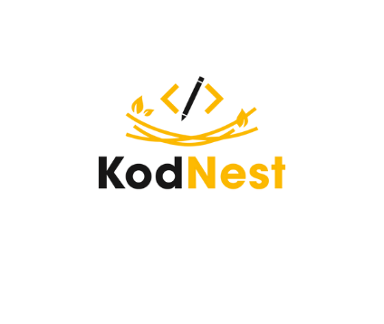

Full Stack Developer

Mangalore

Shashankd.devadiga@gmail.com

8618771857

**Career OBJECTIVE**

A creative and detailed individual has the capacity to develop an effective and efficient solution with no tolerance for errors and possess a positive attitude towards individual goals and an organizational goal.

**Year Qualification College/School University/Board CGPA/Percentage**

* JAVA
* Python
* Data Structures
* CSS
* Sql
* Golang

**AREA OF INTEREST**

* Photocatalytic concrete offers building professionals a unique opportunity to contribute to sustainable development goals.
* Photocatalytic cementitious materials are a promising solution for deteriorating air quality.

#### Experimental study on Photocatalytic Concrete:

* Petroleum refinery waste management -Safe reuse of hazardous industrial waste.
* Approved and funded by Visvesvaraya technological university Belagavi.
* Special concrete M-50 was achieved.

Mechanical and durability characteristics of spent catalyst modified concrete as fine aggregate:

#### Bhandary Construction

KSEEB

St Joseph College of Engineering

2015-17

PUC

Govinda Dasa Pu College

PUE

91.17

9.15

VTU

B.E - Civil

2017-21

**INTERNSHIP**

**MINOR PROJECT**

**MAJOR PROJECT**

* REACT
* GOLANG
* ML
* AI
* Assisted to carry out construction of pile foundations.
* Construction of footing, columns and shear walls.
* Critical Thinking
* Problem Solving
* Teamwork & Collaboration
* Research & Analysis

## **CAREER SKILLS**

* Certified Full Stack Developer from KodNest
* Certified in C & C++ from IIT - Kanpur – NPTEL
* Certified in CSS form University - Coursera
* Jira
* Github
* Html
* Javascript
* Angular-Js
* Manual Testing

## **CERTIFICATIONS**

**TECHNICAL SKILLS**

95.20

Vidyadayinee High School

SSLC

2015

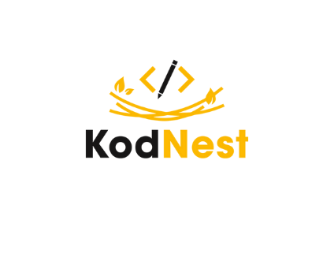

SHASHANK

Full Stack Developer

Mangalore

Shashankd.devadiga@gmail.com

8618771857

**MINOR PROJECT**

**TRAINING AND WORKSHOP**

* CAD Desk- Workshop on designing and modelling of buildings.
* SJEC – Workshop on project management.
* Feel-Employable–personality development.
* I-point soft skill training.
* JV Global aptitude training.
* Webscrapping is successfuly done by using golang and Java.
* Slack bot project is caried out using golang.
* Calculator Application is made with the help of swings.
* Portfolio website of mine is made using html, css and javascript.
* Web servers is done with the frameworks fibre, gin, gorm.

## **ACHIEVEMENTS**



**LANGUAGES**

* English
* Tulu
* Kannada
* Hindi

## **HOBBIES**

* Playing Cricket
* Listening Music

## **DECLARATION**

I solemnly declare that the information furnished above is free from errors to the best of my knowledge and belief.

* Elected as School people Leader
* Lead under-14 district level kabaddi team
* Participated in Engi-Connect, annual technical festival NITK
* Elected Po cadet of NCC unit
* Elected captain of the local cricket team
* Actively participated in tech fest 2018-St Joseph

Engineering College

Date:

Place:

Signature